**DEMONSTRATION OF SECURITY SYSTEM ALARM WITH ULTRASONIC SENSOR**

**ABSTRACT**

**Team:**

Shri Akshita.G(19911A3547)

Gouthami.V(19911A3554)

Naahidha Anjum(19911A3534)

Sayyad Riyaz(19911A3545)

**Components Required:**

* Ultrasonic Sensor
* Arduino UNO Board
* Connecting wires
* Buzzer
* Bread board

**Connections and Circuit Diagram:**

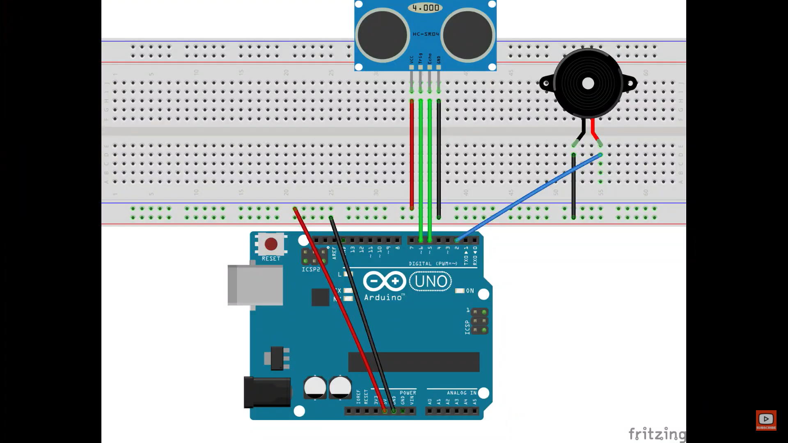

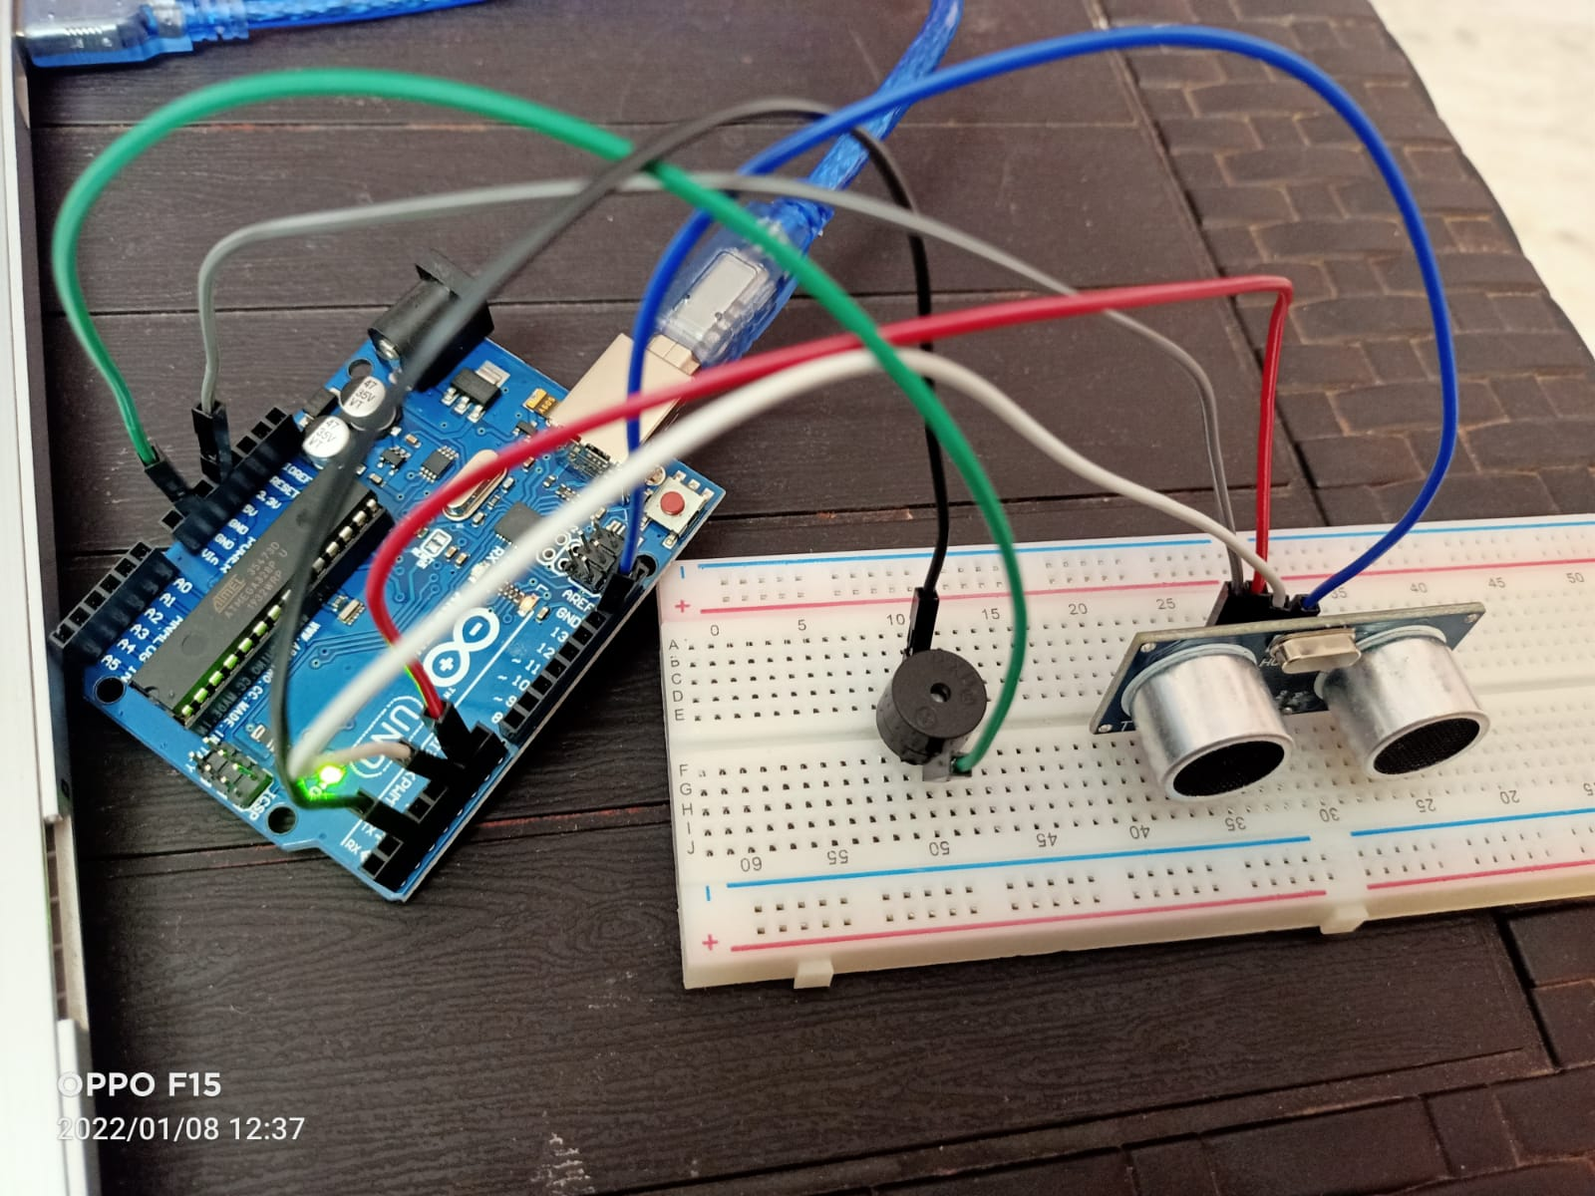

**Practical working:**

**Source Code:**

#define trigPin 6

#define echoPin 5

#define buzzer 2

float new_delay;

void setup()

{

Serial.begin (9600);

pinMode(trigPin, OUTPUT);

pinMode(echoPin, INPUT);

pinMode(buzzer,OUTPUT);

}

void loop()

{

long duration, distance;

digitalWrite(trigPin, LOW);

delayMicroseconds(2);

digitalWrite(trigPin, HIGH);

delayMicroseconds(10);

digitalWrite(trigPin, LOW);

duration = pulseIn(echoPin, HIGH);

distance = (duration/2) / 29.1;

new_delay= (distance *3) +30;

Serial.print("The object is at ");

Serial.print(distance);

Serial.println(" cm");

if (distance < 50)

{

digitalWrite(buzzer,HIGH);

delay(new_delay);

digitalWrite(buzzer,LOW);

}

else

{

digitalWrite(buzzer,LOW);

}

delay(200);

}

**Future Scope Of Work:**

* We can use it for Security purpose with face recognition for the entrance and warn the trespassers.
* We can use in vehicles such as cars, lorries as reversing the vehicles in small streets is a bit difficult so our project can calculate the distance and alert at how much distance the object is at so that collision will be prevented.

**Result:**

When the sensor detects an object it will calculate the distance and with the help of buzzer alarm sound is produced.